Recommendations for FM systems:
There are basically two types of FM systems; the individual ear level devices and sound field systems. For most, but not necessarily all, APD students an individual ear level device is superior to a sound field system. Individual ear level devices include a lapel mic transmitter worn by teacher/speaker and ear level ear piece receiver worn by student. Sound field systems include a handheld mic used by teacher/speaker and ceiling speaker. Sound field systems often fail to address common issues suffered by individuals with APD (ie,, directionality, localization, dichotic listening, speech clarity, signal-to-noise ratios, etc).

- You will need a receiver (worn by student). There are several types of receivers, i.e., Roger Focus (individual ear level device worn by the student with normal peripheral hearing) or an FM boot receiver (which attaches to the bottom of a hearing aid worn by student with peripheral hearing loss). In the case of most APD student’s needs, the Roger Focus is the appropriate recommendation.

- You will need a transmitter (worn by speaker). There are several types of these as well. There is the older version called Roger Touchscreen mic. This is worn on a lanyard or clipped to a belt, with attached corded mic worn on lapel. They are durable and found in many schools. Downside is they are bulky & can create clothing rustling noises (worn around the neck on a lanyard with lapel mic attached via cord). Newer more streamlined version of transmitter is the Roger Select. It has multi-functionality (more connectivity) and is more streamlined and light weight. Teacher can wear it on lapel or on lanyard. It can also connect to multiple student devices, i.e., tablets/smart phones/laptops/etc. It also auto switches from single speaker directional microphone mode to multi-talker omnidirectional mode (as well as having the capability to manually focus the beam of mic pick up in any chosen direction). This is extremely useful when in small groups in a noisy classroom, a study group session, or therapy session.
The Roger Clip on Mic is another option for transmitter. It is very small and discreet and also has some of the multi functionality of the Roger Select device. The main difference is it is far smaller (about the size of a domino) making it both very discreet and easier to lose. There is also the Roger Pen; however, this mic has received many complaints regarding clothing noise as well.

Therefore, for both a school setting, therapy sessions & home remote learning situations I would recommend the Roger Select II mic. It is durable yet more streamlined & more technologically advanced than any of the other options. It also has greater flexibility due to its automatic switching of mic modality operations. Size-wise it is thin and only slightly larger than a silver dollar.

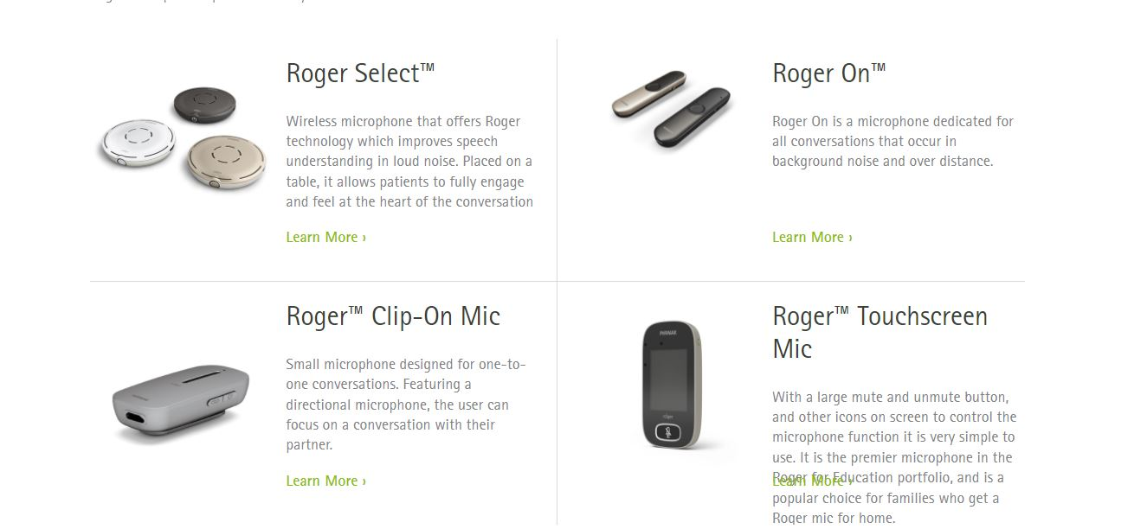

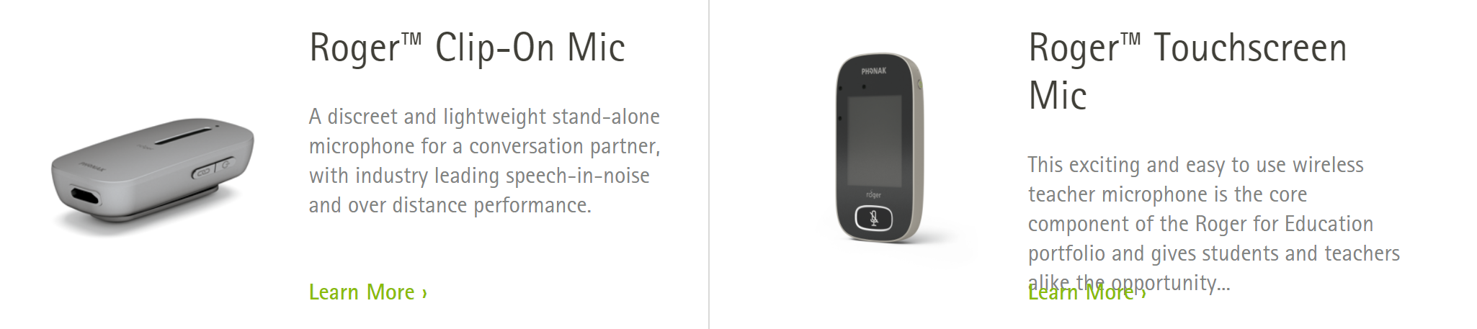

Costs: Purchase from an Audiologist includes fitting & orientation in FM system use (required), 3 years of unlimited professional services (maintenance & repair of devices), 3 years manufacturer’s repair warranty, and 3 years manufacturer’s loss & damage insurance policy (replacement of device if lost or broken).

